Parks Canada Strategic Data Consultation: Phase Two
Submission by OH-Deer Data Consulting
Taya, Matt W., Josh, William, and Matt G.
2025
Table of Contents
Proposal to Parks Canada 2
1. Vegetation Monitoring 3
Activities and Sub-Processes: 3
Key Performance Indicators: 4
Data Accuracy 4
Vegetation Health 4
Real-Time Data Availability 4
2. Visitor Flow Management 5
Quality & KPI: 5
Activities and Sub-Processes: 5
Key Performance Indicators: 6
Facility Utilization Rate 6
Ecological Impact Control 6
Net Promoter Score 7
3. Creation of New Protected Areas 8
Activities and Sub-Processes: 8
Key Performance Indicators: 9
Simpson’s Index of Diversity (Β) 9
Landscape Connectivity 10
Representation of Protected Areas in the System 10
Conservation to Reach National/Global Targets 10
Cost Per Hectare 10
Approved Change of Scope - March 3, 2025 11
Data Sources 13

Proposal to Parks Canada
At OH-DEER Data Consulting, we’re a dedicated team of data engineers focused on delivering seamless transitions and ensuring minimal disruption to your operations. We pride ourselves on providing solutions that enhance data accessibility, agility, and integration.
Parks Canada, by entrusting us with the modernization of your systems, you’ve taken an important step towards improving efficiency, scalability, and data-driven decision-making. We understand the complexities of managing diverse datasets across multiple systems, and to address this, we propose a unified solution that connects all your data sources. This will ensure real-time access, eliminate data silos, and provide a comprehensive view of your information, leading to better decision-making, scalability, and robust security. Our solution also empowers you to create user-friendly reports, making data-driven decisions simpler.
Based on our thorough assessment of your business needs, we’ll help you make three key decisions with data-driven insights:
- Vegetation Monitoring
- Visitor Flow Management
- Creation of New Protected Areas
Our adaptable approach will evolve with your needs, ensuring seamless access to critical data while delivering long-term value and improved resource management. We’re excited to collaborate with you on this transformative journey.

Vegetation Monitoring
Parks Canada must make decisions to protect and restore our national parks and historic sites. A key aspect of this is tracking and monitoring endangered species, and vegetation monitoring plays a crucial role in that process. Parks Canada uses vegetation monitoring and other data to guide important conservation decisions, such as prioritizing restoration efforts and protecting endangered species. This data-driven approach ensures targeted, effective actions to preserve ecosystems.
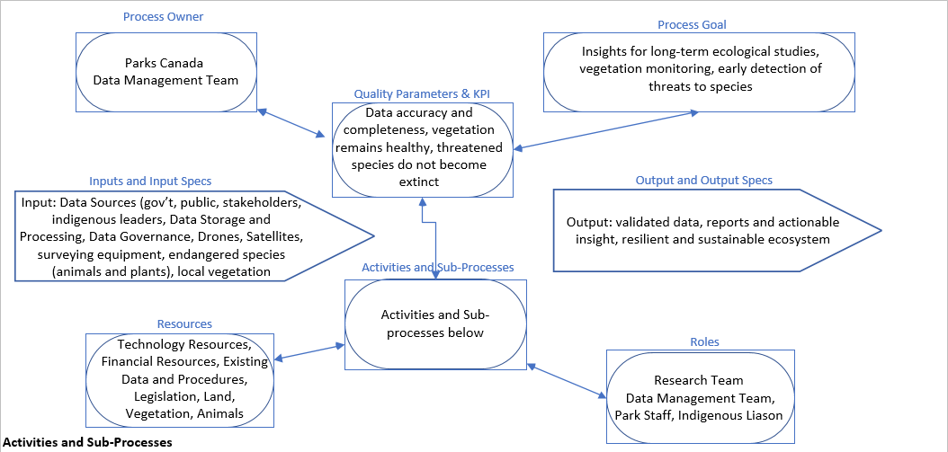

Activities and Sub-Processes:
Data Collection — set up sensors to collect data on vegetation, satellites to capture imagery, observe endangered species and habitants, on-the-ground vegetation survey to monitor growth, grazing, nesting and foraging
Vegetation Health Assessment — use remote sensors and field data to assess vegetation stress, satellite and drone imagery to track health, measure growth and identify potential threats to species and habitants
Vegetation Mapping and Habitat Modeling — GIS-based mapping, habitat modeling, and prediction of species habitat quality and potential threats
Threat Detection and Early Warning — map, monitor and track invasive species, endangered species habitats, climate change impacts and environmental changes to study fire risks, and degradation
Data Analysis and Reporting - Integration of data, field surveys, reporting for decision-making and analyze long-term trends and correlations between vegetation and endangered species behavior
Restoration and Conservation Actions — using data to plan and implement vegetation restoration, management and monitor vegetation recovery and return of endangered species to an area

Key Performance Indicators:

Data Accuracy
- Value: is its ability to ensure that the data used for decision-making in conservation and ecosystem management is trustworthy, consistent, and precise.
- Target: error rate, sensor calibration, acceptable range for measurements
- Measurement: Regular audits of data collection methods and comparison of data sources for consistency.
$$Data Accuracy\left(\%\right)=\frac{Number of Correct Data Points}{Total Number of Data Points}×100$$

Vegetation Health
- Value: is to ensure the sustainability and resilience of ecosystems, particularly in national parks and protected areas.
- Target: vegetation coverage, vegetation growth, invasive species control, habitat suitability for endangered species
- Measurement: Regular vegetation surveys, remote sensing data, and environmental health indices.
$$Vegetation Health(\%)=\frac{Area of Healthy Vegetation}{Total Area Surveyed}×100$$

Real-Time Data Availability
- Value: Real-time data enables Parks Canada to quickly respond to environmental threats and support proactive conservation efforts
- Target: 99.9% uptime, ensuring continuous access for monitoring and decision-making
- Measurement: System uptime logs, data refresh rates, and latency metrics from monitoring platforms
$$Realtime Data Availability\left(\%\right)=\frac{Time Data is Available (TDA)}{Total Monitoring Time (TMT)}×100$$

Visitor Flow Management
Parks Canada optimizes the tourism experience and improves infrastructure by collecting and analyzing visitor data. Visitor data helps optimize capacity management at popular attractions like Banff and Lake Louise, adjusting entry restrictions and services based on demand. Parks Canada plans investments in upgrading campsites and trails. Data also identifies peak periods, guiding seasonal planning and helps allocate resources to high-traffic parks for maintenance and upgrades.
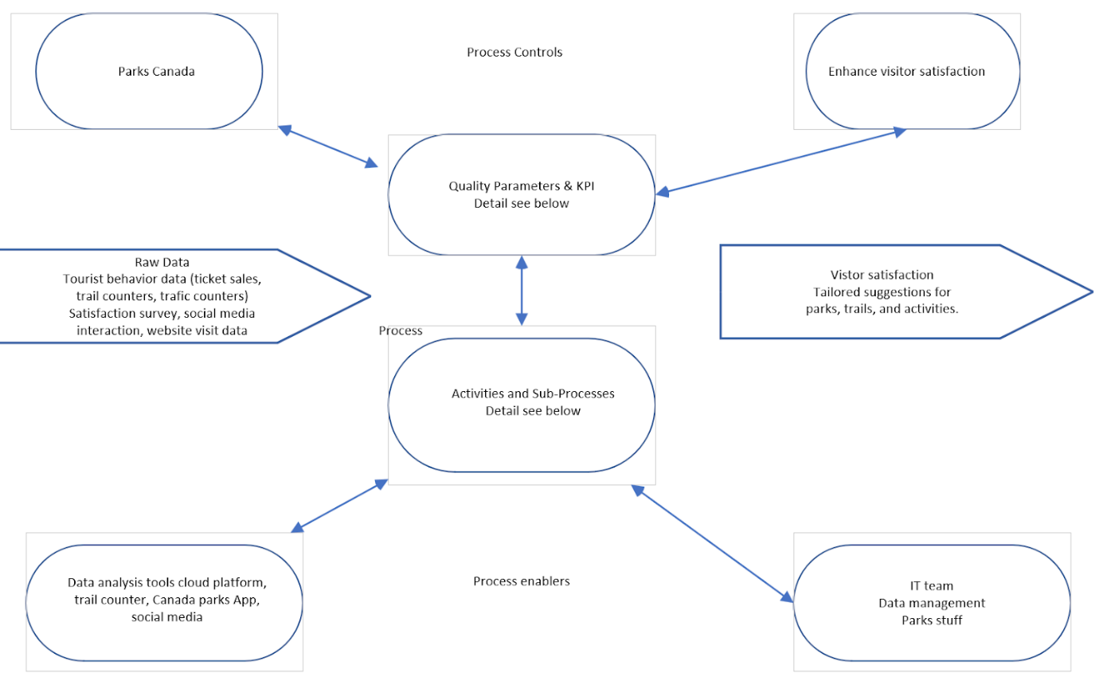

Quality & KPI:
Visitor satisfaction, operational efficiency, facility utilization, seasonality, weather, environmental degradation

Activities and Sub-Processes:
Assess Visitor Demand and Trends
- Data Collection: Use IoT devices to track visitor numbers, behavior, and parking occupancy
- Analyze Trends: Evaluate peak visitation times and underutilized areas
- Adjust Capacity: Implement entry restrictions, vehicle quotas, and staff/resource allocation during peak times

Strategy Formulation and Implementation
- Diversion Measures: Promote lesser-known attractions and off-peak visits
- Infrastructure Planning: Identify and prioritize areas for upgrades based on demand
- Environmental Protection: Protect sensitive areas with “Leave No Trace” and diversion strategies
Monitoring and Real-Time Adjustments
- Real-Time Monitoring: Track visitor flow and key areas via sensors and cameras
- Adjust Services: Modify shuttle schedules, open/close entry points, or allocate staff based on live data
- Visitor Feedback: Collect feedback through apps and surveys to gauge satisfaction
Feedback and Continuous Improvement
- Visitor Feedback Analysis: Gather insights from surveys and behavior data
- Iterate and Improve: Adjust strategies and resources based on feedback and seasonal data

Key Performance Indicators:

Facility Utilization Rate
The ratio of the actual usage of park facilities (e.g., campsites, trails) to their designed capacity.
By analyzing the visitor density during peak hours and assessing congestion levels that exceed capacity. Consider the establishment of new trails or the redirection to alternative existing trails. To reduce the problem of overcrowding on popular trails and disperse the flow of visitors to improve the quality of their experience.
$$Facility Utilization Rate\left(\%\right)=\frac{Actual Usage}{Designated Capacity}×100$$

Ecological Impact Control
The substantial influx of visitors has resulted in significant environmental degradation in the areas surrounding the trail.
This is to track changes in plant species to assess holistic recovery.
$$Vegetation Cover \\ Improvement\left(\%\right)=$$ | $$\frac{PostDiversion NDVI-PreDiversion NDVI}{PreDiversion NDVI}×100$$

Net Promoter Score
NPS can quickly and quantitatively reflect tourists' satisfaction and loyalty with the overall experience in the park.
$$NPS=\%Promoters-\%Detractors$$
Where promoters are the percentage of visitors willing to recommend parks to others based on their experience and detractors are people who would share negative opinions with others, also as a percent.

Creation of New Protected Areas
Approving new parcels of land to be appropriated into its Land Portfolio is perhaps the most important decision Parks Canada’s leadership is responsible for. This process is central to its value-proposition to protect and Canadian ecological and cultural heritage for current and future generations. This process affects the organization’s finances, from the fixed costs of land acquisition to the long-term impact on operational budgets through increasing the aggregation of year-over-year management and maintenance costs.
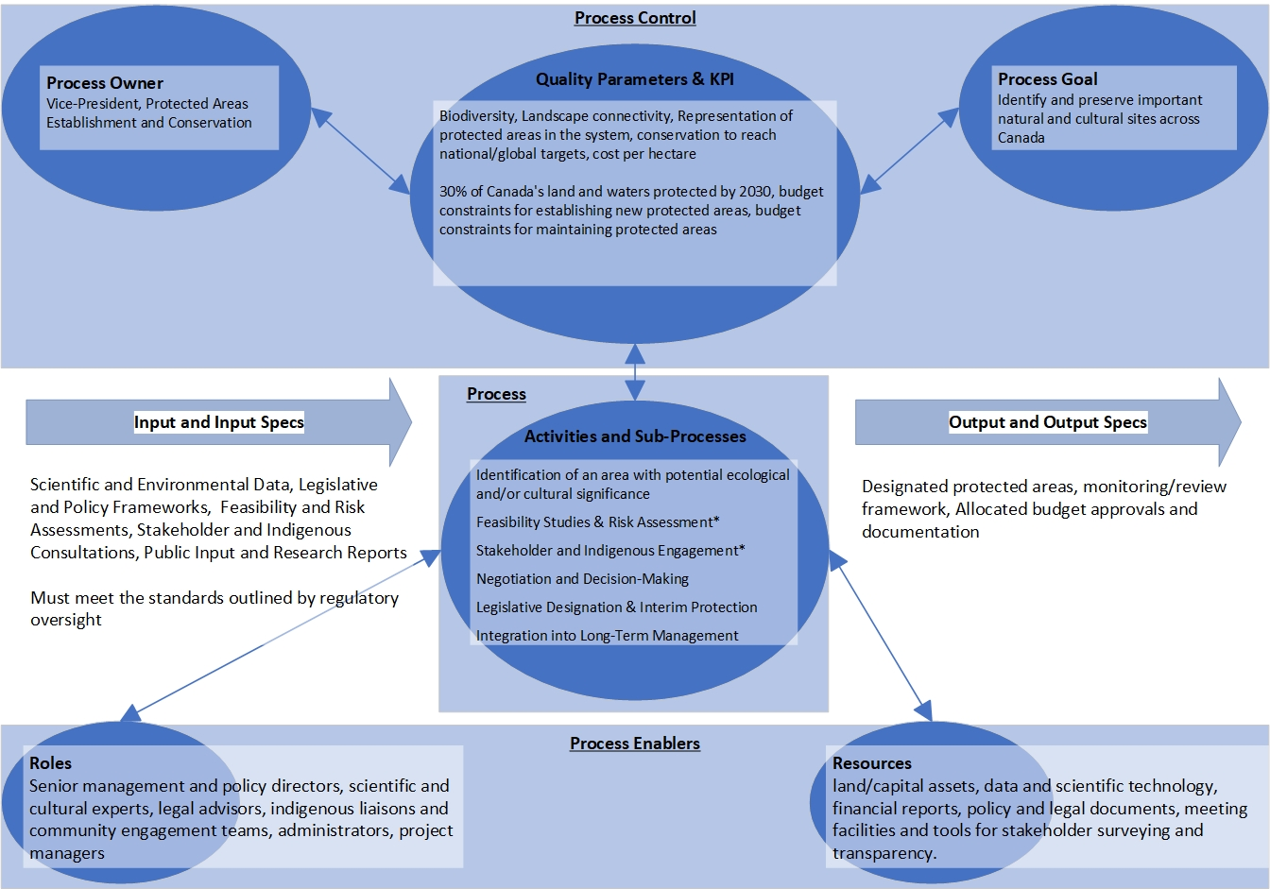

Activities and Sub-Processes:
Identification of an Area with Potential Ecological and/or Cultural Significance:
- A potential need for designating a parcel of land is identified by a stakeholder
- A request is made to create a proposal for designating the land in question for protection

Feasibility Studies & Risk Assessment:
- Conduct detailed environmental impact assessments and risk analyses (including climate change vulnerability)
- Evaluate socio-economic and cultural implications through targeted studies
Stakeholder and Indigenous Engagement:
- Hold consultations and workshops with local communities, Indigenous groups, and government partners
- Develop and secure impact and benefit agreements or memoranda of understanding that define shared management responsibilities
Negotiation and Decision-Making:
- Work through negotiation stages with partners to refine boundaries, management plans, and co-management arrangements
- Secure necessary approvals through internal reviews and consultations
Legislative Designation & Interim Protection:
- Finalize the designation of the area through legislative processes or ministerial approval.
- Implement interim protection measures (e.g., temporary park status or management plans) until full designation is formalized
Integration into Long-Term Management:
- Develop comprehensive management plans (including zoning, visitor services, and ecological monitoring)
- Establish ongoing monitoring, reporting, and periodic review to ensure long-term conservation outcomes

Key Performance Indicators:

Simpson’s Index of Diversity (Β)
$$B= \frac{\sum_{i=1}^{S}{(n_{i}\left(n_{i}-1\right))}}{N(N-1)}$$
- S is the number of species
- $n_{i}$ is the number of individuals counted that belong to species i within the sample S
- N is the total number of individuals in all species in the area

Landscape Connectivity
$$Connectivity Score(\%)=\frac{Area of Connected Corridors}{Total Area of Protected Zones}×100$$
- This is used to calculate the ability and usage of connected corridors that allow wildlife to move between protected areas

Representation of Protected Areas in the System
$$EcoSystem Representation(\%)=\frac{Area of EcoSystem Type Representated}{Total Area of that Ecosystem Type in Canada}×100$$
- This focuses on the amount of how much of a particular ecosystem or landscape type is protected within the proposed area compared to its total distribution across the country

Conservation to Reach National/Global Targets
$$Global Target Contribution=\frac{Protected Area}{Target Area}×100$$
- This is the amount of the protected area relative to the national or global targets
- Follows how close to the goals/targets the conservation efforts are

Cost Per Hectare
$$Cost Per Hectare=\frac{Total Aquisition Costs of Land Parcel (CAD)}{Total Park Area (ha)}$$
- Financial considerations must be made when establishing new parks/conservatories to manage budgetary limitations

Approved Change of Scope - March 3, 2025
A shift in strategic funding has caused the need to update the scope of this project. The trail cam project to install a network of 3600 infrared thermal censors for monitoring wildlife movement patterns has been delayed.

An internal data audit has revealed that some data integral to the initially scoped solution is unavailable at this time. Proposals for data collection projects to rectify these gaps are being prepared. Presently, Parks Canada would like to proceed with a building out a solution for the following topics:

Ecological Health and Threat Assessment - Provide Parks Canada executives and lead ecologists with convenient visibility into the ecological health across 48 national parks and reserves to empower resource allocation for ecological projects.

Visitor Experience Management - Do visitors to Canada's many national parks enjoy a positive experience. Do they currently have sufficient parking spots for visitor demand?

2030 Preservation Commitments - Evaluate how Canada is progressing towards its 2030 land and marine preservation commitments and if strategic adjustments need to be made to meet deadlines.

These topics are simply redefining the previously defined areas of interest after the removal of the below sections and sub-sections from the original Phase 1 report, after identifying data availability constraints:

- Real-Time Data Availability
- Under Visitor Flow Management, Ecological Impact Control
- Landscape Connectivity
- Cost Per Hectare
Parks Canada has provided Oh-Deer Data with a limited dataset to build a proof-of-concept solution with a limited dataset based on the key areas they would like to focus on moving forward. It is mutually understood that this solution will not necessarily convey the full extent of value provided by the completed solution once integrated with the concurrent data audit.

Oh-Deer Data is scheduled to demonstrate this new iteration of the solution to Parks Canada’s decision makers on Thursday, April 17, 2025. Parks Canada has also requested that the solution be built out within Microsoft’s Power BI at this stage.

While scaling the solution with Microsoft’s Fabric platform may still be considered, the client has expressed frustration with some of the usability and feature-sets of Fabric during the development phase of this project, especially when collaborating on the development of a dashboard across multiple workstations and the usability of the ETL feature-set. Oh-Deer Data has committed to relaying this feedback to Microsoft’s Fabric sales team and look at scheduling a luncheon to troubleshoot these issues within the first half of May.

Data Sources
- Direct Communications with Parks Canada Personnel
Additional data and context obtained via email and telephone conversations with Parks Canada staff.
- Forest Non-Native Vegetation – Kootenay National Park
Data on invasive plant species in forested areas of Kootenay National Park.
Dataset: https://open.canada.ca/data/en/dataset/5496f5b5-92c6-4b9a-9f9a-bb63c21c7a56
- Forest Non-Native Vegetation – Yoho National Park
Data on invasive plant species in forested areas of Yoho National Park.
Dataset: https://open.canada.ca/data/en/dataset/yoho-non-native-vegetation
- Fundy National Park Visitor Statistics (2011–2014)
Data on visitor numbers to Fundy National Park during the specified years.
Report: https://parks.canada.ca/docs/pc/attend-eng.pdf
- Natural Resources Canada
Provides comprehensive data on climate, wildfires, forests, and forestry.
Website: https://natural-resources.canada.ca/
- New Brunswick Travel Information
Details on popular hiking trails and natural attractions in New Brunswick.
Website: https://tourismnewbrunswick.ca/
- Parks Canada – Conservation and Restoration (CoRe) Program Report (2023)
Details on initiatives aimed at protecting nature and biodiversity within Canada's national parks.
Report: https://parks.canada.ca/agence-agency/bib-lib/rapports-reports/conservation/conservation-2023
- Purple Loosestrife Monitoring – Prince Edward Island National Park
Annual data on the prevalence of the invasive species Lythrum salicaria (Purple Loosestrife) in PEI National Park.
Dataset: https://open.canada.ca/data/en/dataset/243ee856-8d48-4e41-9392-0fae498db28e
- Species at Risk Act Overview (Parks Canada)
Overview of the SARA program and related conservation efforts.
Website: https://www.pc.gc.ca/nature/science/especes-species/itm1
- Species at Risk Public Registry
Official repository for documents related to the Species at Risk Act (SARA), including species assessments, recovery strategies, and action plans.
Website: https://www.canada.ca/en/environment-climate-change/services/species-risk-public-registry.html
- Conservation Land and Marine Areas in Canada
Overview of conservation areas in Canada and other countries
Website: https://open.canada.ca/data/en/dataset/c5569075-2b1c-4320-81a9-7ee582dd628e
- Biodiversity Data – PEI Odonata
PEI National Park Odonata biodiversity data
Website: https://open.canada.ca/data/en/dataset/ce777149-3cb9-4ac2-a133-0924fef16c6e
- Biodiversity Data – PEI Bank Swallow
PEI National Park Bank Swallow biodiversity data
Website: https://open.canada.ca/data/en/dataset/8481aa26-a577-49e0-9f55-5ce2df9864dc
- Biodiversity Data – PEI Fish
PEI National Park Fish biodiversity data
Website: https://open.canada.ca/data/en/dataset/192ccf66-987a-4f95-9c69-910383d9875b
- Banff Traffic Data
The Town collects data to determine solutions to traffic flow problems during peak season.
Website: https://banff.ca/1288/2023-Traffic-Data

- Banf Visitor Data
Got it from parks Canada email. I did connect with them through SAIT email.

- Net Promoter Score (Dummy Data)
According to the Banff annual report, build the whole dummy data.
Website: https://plansandreports.banfflakelouise.com/2023annualreport

